THE POLLUTION DETECTIVES
PROTOCOL FOR SURVEYING DRINKING WATER IN SCHOOLS FOR LEAD
September 9, 2019

The following manual is an emerging piece of work.
If you have suggestions to improve it, please reach out to us.

There are no federal regulations that K-12 or nursery schools have their drinking/cooking water surveyed for the presence of lead. Only 7 states have any requirement that schools be tested for lead in drinking water. This leaves millions of children at risk. The presence of this risk has been confirmed by findings of serious levels of lead in the water when some school systems have voluntarily examined their water. (You can see examples at www.thepollutiondetectives.org)

You need to know is that some people are going to be anxious when you tell them you want to test their school’s water for lead.

If you find lead, we also know that those same people will feel threatened and may try to discredit your efforts.

They may start by challenging your ability to do such surveying by citing your age, your lack of scientific credentials, or your bias, or your equipment.

They will challenge the kind of instrument you used, your training, and the protocol you used to do the sampling and the testing.

We have found that the best defense is very careful documentation. We have seen skeptics flip into the “believer” column when they actually see how careful our teams are when collecting the samples and doing the analysis.

A key first step is vocabulary – you are “screening” the water for lead, not “testing” it. The reason for this word choice is that there are several different legal definitions for “testing”, most of which are way too expensive and time consuming. These definitions were created before the presence of the newer, more accurate, cheaper, and quicker instruments we recommend (and can lend you).

SO DO NOT SAY YOU ARE TESTING –
TELL THEM YOU ARE SCREENING

If you set out to do a “screening”, and you find troubling results, you can notify appropriate parties, and they can take the responsibility to “test” the results, meeting whatever legal standard they choose. The good news is that you will have narrowed the number of places they might have felt a need to “test”, because your “screening” came in below the level of concern on most of the samples taken. You saved them a lot of money, and identified an area of risk they can fix.

COST

Each screening sample analyzed by The ANDalyze AND1100 fluorometer requires a one-time use “consumable”. These cost around $10.00 each, and you get the results immediately. If the more traditional techniques and equipment are used, each TEST costs about $50.00, and takes several weeks to get back from the laboratory.

So if you sample 10 faucets and fountains (a typical primary school) your cost will be about $100.00 - and if you have a troubling finding, the school system can pay for the traditional testing of that specific location if they want to double check.

We will donate the appropriate number of consumables, so this project will have no cost to you.

WHERE TO SAMPLE

You do not need to sample every place water comes out of a pipe in a school; just the drinking fountains and cooking faucets. The average school has one drinking fountain for every 100 students, or one for every 50 if they have a “tall” and “short” set next to each other. In addition to that, most schools have kitchen sinks for preparation of food. You want to “screen” them as well. Unless every fountain you screen comes up with troubling levels, you do not need to sample all the faucets in the bathroom sinks – people do not tend to drink from them.

School systems that have done various kinds of inspection tend to find one out of every 8 samples taken have concerning results. This is because most of the lead found is the result of older faucets and fountains, not faults with the city water supply or the plumbing inside the school.

However, if almost every one of your samples are concerning, prudence would suggest that the municipal water system be asked to survey the water entering the school.

If the public water supply folks get involved, there are two places this second level survey should occur. They are on either side of the water meter where the school plumbing connects to the public water system. If the sample is drawn before the water meter, and comes up clean, the problem is not with the city system – it is on the school property. If a concerning sample is taken at a faucet on the school side of the meter immediately after the pipe enters the school building, the problem is probably an old pipe connecting the city system to the school plumbing (between the meter on the street and the school wall). In many cases if the school system fixes that one piece of underground pipe the problem is resolved.

In some cases, particularly in older schools, the plumbing inside the school that carries water to showers, toilets, and fountains may need to be replaced. This is very, very rare.

BE AWARE THAT SCHOOL SYSTEM LEADERSHIP MAY BE CONCERNED ABOUT YOUR EFFORT OUT OF FEAR THAT THE SOLUTION WILL BE COSTLY

Many school systems are deeply concerned that you will find results that indicate they have to replace the entire plumbing of the building. You can reassure them that research shows that if the system has 400 students and uses “short” and “tall fountains”, and two faucets in the food preparation area, a maximum of maybe two will need to be replaced. Less than $1,000 per school.

FOLLOW THESE STEPS

- The first thing you have to do is obtain written permission to do the screening (not a “test”, right?) of the drinking water for lead. You will find a draft of a form at the end of this document that you should ask your principle to sign.

- The website of the equipment vendor is located here: http://andalyze.com. On it you will find instructional videos, a bibliography on the subject of heavy metals (including lead) in drinking water, and links to stories about school systems that have discovered a need for remediation. There is a lot on that website, so do not just read the first few pages.

- When you receive the meter, you will find enclosed a form that needs two signatures - the student, and their adult mentor. The form says that received “X” number of monitors, serial number xxxxxxx, you will follow these directions faithfully, including uploading the data and and all required photographs, and that you will return the monitor to us within 10 days of receipt.

- Work with school or school system leadership to identify a contact person familiar with the interior of the building who can let you into the building before classes begin or on the weekend, and if required guide or accompany you’re your screening team. This can be a teacher, principle, or member of the security or maintenance staff.

Be aware of the fact that sampling for lead in the drinking water should be done after the fountain or faucet has not been used for 8 hours. This ensures a better sample. We have found it easier to do our sampling on Saturday or Sunday, or another school holiday.

This means that whomever is your contact to let you into the building must be willing to work for several hours on those days. Each sample takes about half an hour to create the map, photograph the sample gathering, capture the water sample, bring it to the temperature range suitable for processing, process, photograph the sample gathering, photograph the results shown on the meter. You can upload the photos and write any report and upload the photos at home.

- Get blueprints or floor plans, and working with your contact person, mark the locations of fountains and faucets. This can be a regular blueprint, or a hand drawn sketch. If it is hand drawn, make it neat so it can be on any poster or science fair exibit.

After it is marked, take a photograph of it, and upload it to your folder on Google Drive.

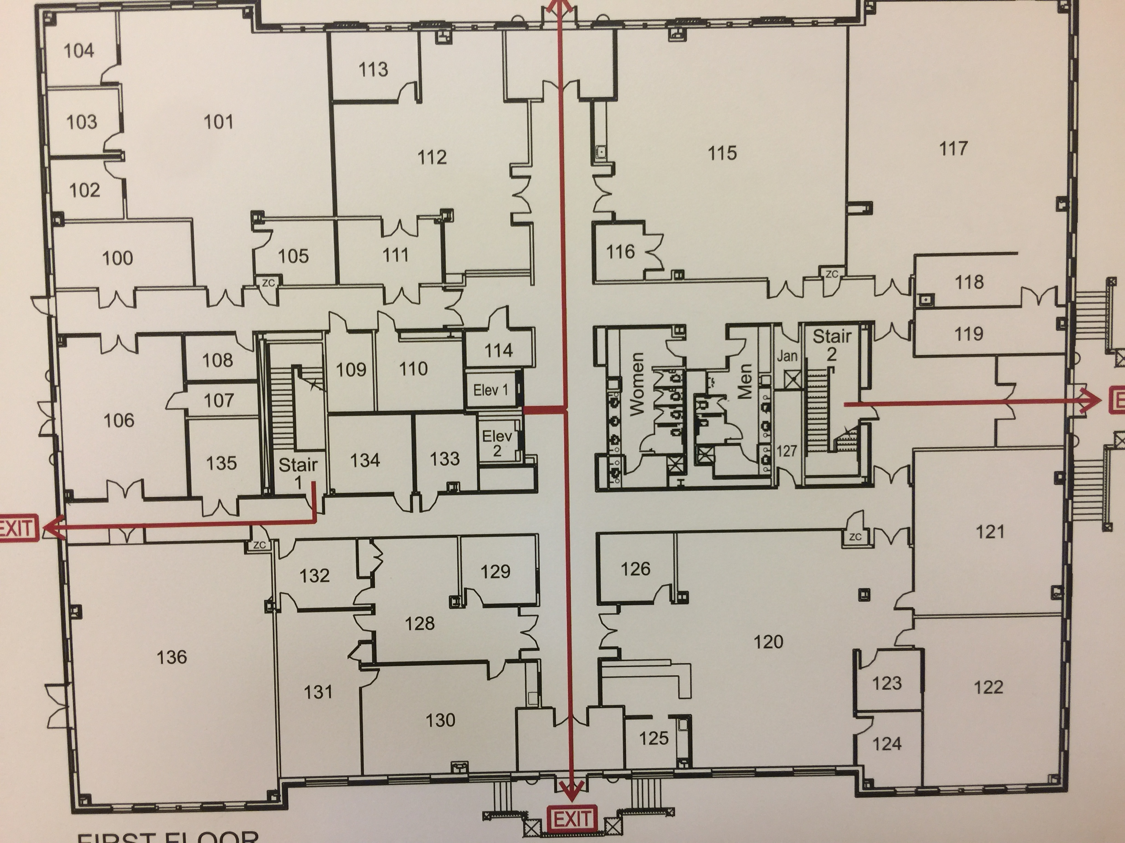

- Using this map, plan placement of signs reading, “Water survey under way – do not use”. Have them installed at close of business the night before sampling.

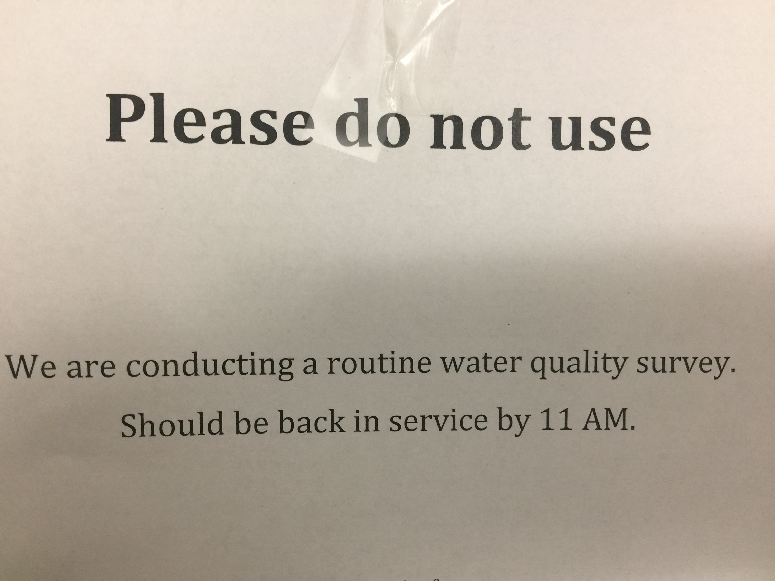

Upon arrival at the vacant school, you need to calibrate your meter. This is to make sure that your results are reliable. You will find directions about how to do this with the meter. Basically, you take a sample of pure water that is provided you, add some lead water of known quantity to it (which we give you), and run it through the meter to make sure the correct amount is detected. You photograph that process and result, and you have begun to demonstrate your results are reliable.

For details on how to do the calibration, please see page 1 through 7 of the booklet shipped to you with the meter.

PAY CLOSE ATTENTION TO THE GUIDANCE ABOUT KEEPING THE CONSUMABLES WITHIN THE REQUIRED TEMPERATURE RANGE. IF YOU PUT THEM IN A HOT CAR, OR LEAVE THEM OUTSIDE IN A CAR ON A COLD NIGHT, YOU CAN RUIN HUNDREDS OF DOLLARS WORTH OF SUPPLIES.

When you open the foil envelop containing the consumable testing supplies, you will see a ¾” by 1½’ clear plastic envelope ‘pillow pack’. If it is not deep blue, set it aside and go on to another foil envelop, because the pillow pack is telling you that the consumable is no longer within standards. IT SHOULD LOOK LIKE THE ONE ON THE RIGHT

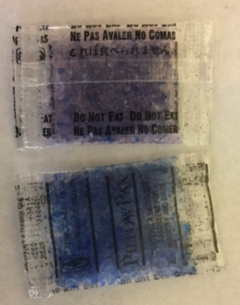

Create a log upon which you record the sample location, time of the sample, the sample fountain code (A, B, etc.) and time taken. Also note who took the sample and who processed it. (Taking a photo of a student is discouraged and may be illegal in your state unless another student takes it - best check that out. On the other hand, if this is for a science fair, that may be a valuable ingredient to your poster session – you are free to have an image of yourself doing the work.)

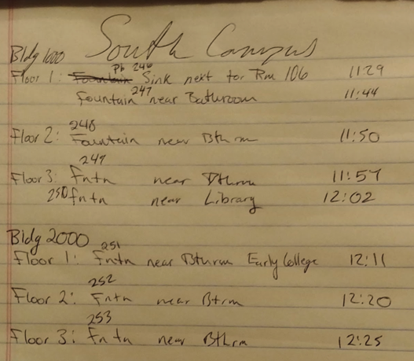

- Go to first location, and take a photo of location. Label your glass sample holder. Make sure you put the date, building name, location inside the building, and maybe time on the label.
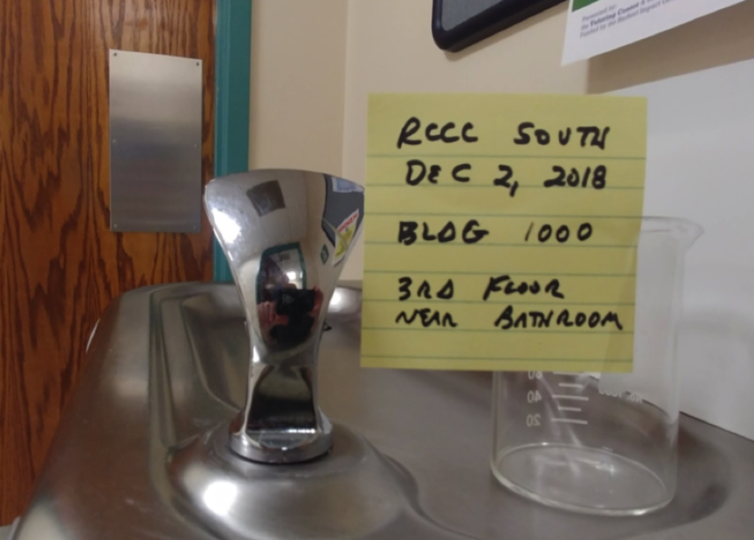

- Following the map you planned out, take the rest of your samples all at once. Remember to take a photo at each location. (

We have it way more efficient to collect and process ten samples collected in laboratory beakers we loan. Make sure they already labeled according to the map of the planned sampling locations. This allows you to take the series of samples, remove the “Do not drink” signs, and retreat to a coffee lounge or other quiet location where we process the samples in the order they were taken.

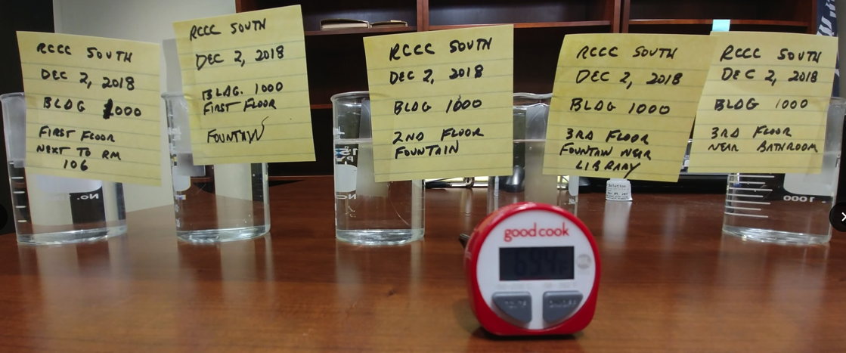

- Make sure the samples are within the desired temperature (70 - 90 degrees Fahrenheit) before putting them through the meter. You can bring them up to temperature using a heating pad or a glass cake sheet filled with warm water.

- Just as you did when you calibrated the meter for this particular school, open the lid on the meter. When inserting the clear plastic “tube” into the meter, it is possible to do it wrong. Insert it TRIANGLE MARK FORWARD, and make sure the cover can be closed before putting the green DNA sample on top.

- Take a photo of meter reading with the labeled glass water holder next to it so everyone can see what sample gave what result. In this example, the reading is “BELOW 2ppb”

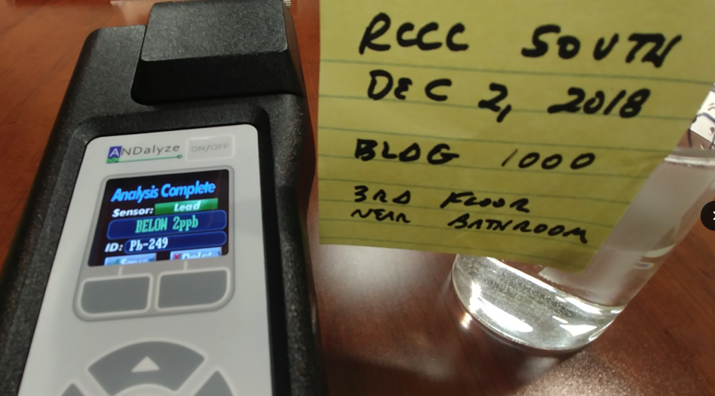

- Go to the Google Drive folder assigned to you and upload all photos, with the photo of where the sample was taken from right next to the photo of the results, with the same label showing in both photos.

Other lessons learned:

If you find any sample reports out above 12, please repeat the test using the same sample. Since the legal threshold for action is 15 ppb, you want anyone who views your results to have faith in a concerning number.

We have found it useful to bring a role of paper towels or a dishcloth to clean up any water spills.

We furnish you thin walled laboratory quality glasses of the same size because if the sample is too cold to process, you can place it in a sink with warm water and it will get to the needed temperature quickly. It takes a lot longer to adjust sample temperature in a heavier glass.

We welcome your feedback and collaborative efforts to make this a successful national initiative to improve our schools, and reduce the risk of lead damage to young brains. If you have any questions please contact us at:

You can see more about our efforts to “make the invisible visible” in the realm of public health at www.thepollutiondetectives.org

Francis Koster Ed. D.
President
The Pollution Detectives Inc. ( a 501-c-3 tax exempt organization)
1012 Westlake Drive
Kannapolis NC 28081

