THE POLLUTION DETECTIVES
PROTOCOL FOR SURVEYING INDOOR AIR QUALITY IN SCHOOLS

The purpose of this document is to make sure that individuals who are sampling air inside a school are doing it correctly. It is not intended to explain the social policy or the science behind this project. For a detailed history of those issues and the huge opportunity to improve America’s schools, see the downloadable document found when you click on “Download a useful brochure” in various menu’s on our website. The document is called:

Right under our noses

A simple solution for improving student success that will work
in many low performing North Carolina schools

This document can also be accessed by clicking here

We lend our equipment to students, parents, teachers, and administrators.

These are the steps you should take to successfully sample a school’s Indoor Air Quality:

- Be advised that we use email a lot in this process. We require that communication sent to any student younger than 18 also be copied to an adult who is either an employee of the school system, or the student’s parent or guardian. So before you can begin, you need to send us the complete contact information for those individuals. You will find a form attached (See Attachment A) to this document with all the required fields.

Once we have your paperwork (either scanned/emailed, or original paper copies) we will set up a school system/individual school page for you on Google Drive. You will use this to document everything about your project.

- Write a description of your goals, metrics, and ideal timeframe. It takes a minimum of 5 classroom days for each indoor air sample to be taken (you can install on Friday afternoon, and remove the following Friday, or install on Monday and remove on Friday, for example). Depending on the size of your school, and the availability of our monitors from our inventory, it may take as little as a week, or as long a month (4 sampling weeks) to collect a suitable amount of data to be able to draw conclusions. See Attachment B.

Be advised that many schools have more than one air conditioning system, particularly if the school was built in stages. You need to talk to your building maintenance staff to understand the design. You need to make sure you get enough samples from each of the different systems.

Think of this space conditioning system as if it were a tree, with a central trunk and some branches. It would be desirable, but not necessary, to monitor the first and last room on every branch of the tree.

A single large HVAC system can have a number of pipes or ducts that service
different parts of the building. For example, in a hallway with 6 classrooms on each side of the hall, the classrooms on the left side may have different piping or ductwork to carry the air, than the classrooms on the right side of the hall. In a surprising number of cases, even though the air conditioning was all done by one big central machine, some classrooms are great, and others across the hall are not. This has to do with various internal parts and pieces of ductwork hidden in the ceiling that may need adjustment.

In other cases, your school air conditioning equipment may have half a dozen different “trees,” each with their own “branches”.

And in still other cases, each classroom has it’s own individual air conditioner.

Either copy a set of plans you are given or sketch out the floor plan of the building and indicate which air conditioning system “branch” works for what classrooms. Do not plan on monitoring dining halls or gymnasiums – stick to classrooms (and offices if you suspect issues in them).

You do not have to monitor every classroom – but you should monitor every ‘tree branch’.

Depending on the model of the monitor we lend you, at the end of the 5 day active classroom monitoring time, you may need to plug the monitor into a real landline telephone line and push a button to upload the data to the library so that a report can be produced.

When we ship you the monitors, we will send you instructions on how to do that which are specific to the monitors we send.

Attachments

Please complete Attachment A and Attachment B and return them to us. You can scan the document and attach it to an email to info@thepollutiondetectives.org, or send it by first-class mail to:

The Pollution Detectives Inc.
P. O. Box 1203
Kannapolis NC 28082

Attachment C is a receipt for the monitors we send you. When you get the equipment please sign the receipt and send a copy back to us for our records. When your project is completed and you send the equipment back to us, you will sign the receipt again, indicating you are returning everything you received.

Attachment D describes proper monitor placement.

Attachment E is a log sheet to help you keep track of monitor placement.

ATTACHMENT A

CONTACT INFORMATION FOR THE INDIVIDUALS CENTRAL TO THIS PROJECT
Send this to thepollutiondetectives@gmail.com

Primary Investigator (The students, parent or employee actually placing monitors and managing the data, preparing the science fair project, etc.)

Name

Personal Telephone

Address for first class mail

Email address

School or Institution

School Address

School Main Phone Number

URL or web address of school’s website

Our liaison at the school (or supervisor of the student’s work)

Name

Personal Telephone

Address for first class mail

Email address

Relationship to student (Parent, Teacher, Science Club Mentor, etc.)

School or Institution

School Address

School Main Phone Number

URL or web address of school’s website

Please give us the contact information for other members of your team (STEM project members, or Environmental Club, etc.) COPY THIS SHEET IF NEEDED.

Name

Personal Telephone

Address for first class mail

Email address

School or Institution

School Address

School Main Phone Number

URL or web address of schools website

ATTACHMENT B
INDOOR AIR QUALITY MONITORING PLAN

- Develop a goal statement: An example of this goal statement might be “We intend to monitor indoor air quality for 2 different air conditioning systems serving the Bill Nye Middle School located in Westport Tenn. The school has 36 classrooms, and we intend to sample air quality in 10 of them. The optimal time to sample is the weeks between February 29th and April 15, 2019. The monitors will be placed and removed by the school’s STEM club, under the leadership of Ms. Jane Smith, a Junior STEM student, under the supervision of Ms. Harriet Jones Ed.D. Science Department Chairman”.

Send us a scan or fax of this goal statement along with the building sketch (Item 2 below).

- Send us a scan of the building blue print or sketch of the building floor plan that contains the air conditioning layout. Indicate which hallways/classrooms are “branches of the tree” from what central air conditioner, and mark which rooms you intend to put monitors in. Count up the number of monitors needed (10 monitors for a week, or 5 for two weeks, or similar). Make sure this matches your goal statement.

- After you have sent us Attachment A and Attachment B (this document), we will send you the monitors you requested, along with a receipt (Attachment C) that will list all the monitors we sent you by serial number. You will be asked to sign, scan and send the receipt back to us immediately, or send us a paper copy at our address (on the receipt).

- When you finish your monitoring, you should take the same receipt, check to make sure you are returning everything we sent you, and sign it again on the line labeled “Student signature at returning”.

ATTACHMENT C
EQUIPMENT RECEIPT

The Pollution Detectives Inc.
P. O. Box 1203
Kannapolis NC 28082
704-616-8024

SCHOOL:
STUDENT NAME AND CONTACT INFO:
PRINCIPAL/FACULTY MEMBER NAME AND CONTACT INFO:
TYPE OF MONITOR (check one): AIR _____ WATER _____
STUDENT SIGNATURE AT ARRIVAL OF EQUIPMENT: __________________________________________________________________
STUDENT SIGNATURE WHEN EQUIPMENT IS RETURNED __________________________________________________________________

MONITOR # | SERIAL # | DATE SHIPPED | DATE RECEIVED | DATE RETURNED
MONITOR # | SERIAL # | DATE SHIPPED | DATE RECEIVED | DATE RETURNED

ATTACHMENT D

Monitor Placement

All monitor placements are to be documented by photos (which should not include children’s faces) that will also be uploaded. Each photo should include the school name, date of placement, teachers name and room number and serial number of the Monitor. We have found that placing a yellow sticky note on the monitor and holding it up to the room number is a convenient way to do this.

You should also complete the installation log, found in Attachment E.

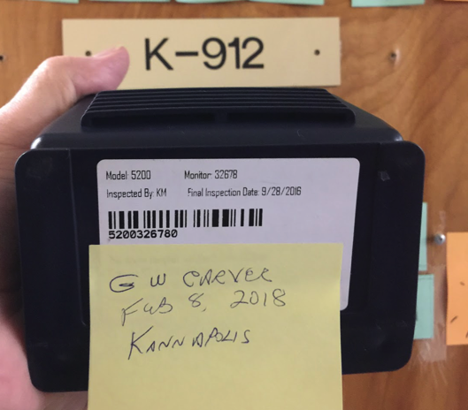

Each monitor, regardless of manufacturer, has a small fan, and an area where air is sucked in, and after electronic sampling, pushed out. This goes on continuously. It is vital that there be no external blockage of either intake or exhaust.

Monitors should be placed about waist high, away from windows, copy machines, laboratory Bunsen burners, and other mechanical or electrical devices that would falsely present the overall average air quality in the room. Avoid placing monitors within 4’ of an air intake or exhaust vent in the room.
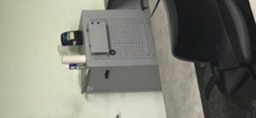

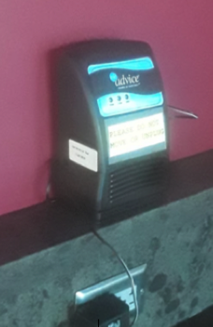

Here are two examples of bad placement – in the first, you can see that the back vent where air is supposed to exit the monitor is blocked. In the second, the monitor was placed on top of some device that is likely to influence monitor readings.

Take a photo of where the monitor was placed in the classroom for documentation, and upload it to the Google Drive page we created for your record keeping.

This is an example of a good placement.

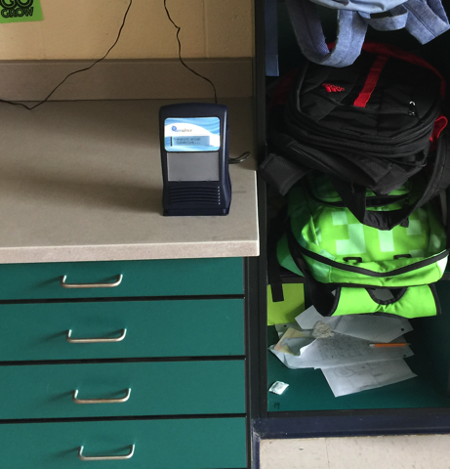

ATTACHMENT E

The Pollution Detectives Inc.
P. O. Box 1203
Kannapolis NC 28082
704-616-8024

AIR EQUIPMENT PLACEMENT LOG

SCHOOL NAME __________________________________________________________________________

INSTALLER | BUILDING | CLASSROOM # 0R OTHER LOCATION | MONITOR # | DATE | TIME | PHOTO TAKEN  Y/N
INSTALLER | BUILDING | CLASSROOM # 0R OTHER LOCATION | MONITOR # | DATE | TIME | PHOTO TAKEN

